Let’s Address YOUR S&OP Issues and Questions
I want to talk about what interests you. Please come prepared to surface issues and ask questions regarding your S&OP process. Could be process steps, agendas, the S&OP calendar, the S&OP document format and content, getting people to show up, data trauma, tying S&OP to finished goods, tying S&OP to your ERP system, performance metrics, getting the sales folks excited about it, and/or getting top management support and buy-in. Based on doing 44 of these over the years, I’ll do my best to share what has worked for me and my clients.

Bio
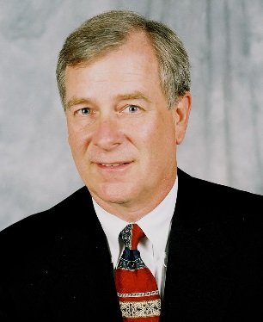
John E. Boyer, Jr., PE, CFPIM, is President of J. E. Boyer Company, Inc., a management education and consulting company. He has 46 years’ experience as a manufacturing professional, consultant, and university educator including Rockwell International, Emerson Electric, and Weber State University. He has completed 44 S&OP design and implementation projects in a wide variety of industries including metal fabrication, electronics, automotive, sporting goods, and healthcare. John has a BS-IE from Lehigh University and an MBA from Utah State University, is a frequent speaker for APICS chapters and other professional organizations, and has made 29 APICS International Conference presentations.

